Chapter 19 Exercise: R-19.3,

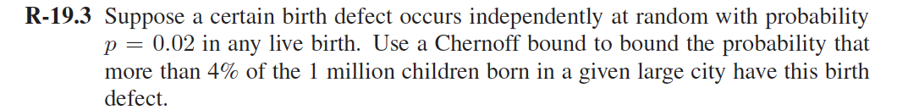

Let X be the random variable that occurs a certain birth defect:

μ=E[X] = = = 20000

Note that 4% of the votes would be 1000000\* 0.04 = 40000.

By Chernoff bounds, for 𝛿=1, upper bound is

C-19.4,

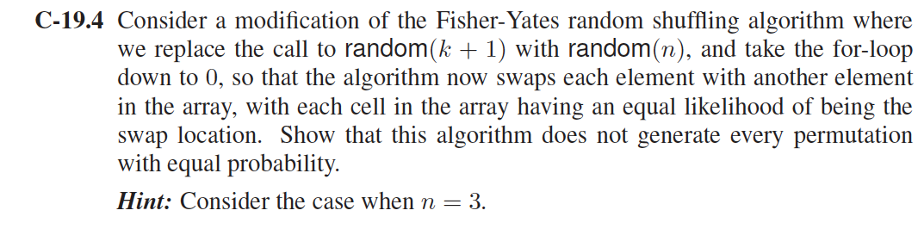

Answer:

There are 𝑛n possibilities how the algorithm can choose random numbers, each with equal probability, and each producing some permutation. There are 𝑛! possible permutations. But 𝑛n is not divisible by 𝑛! if 𝑛≥3, therefore the permutations cannot all be the result of the same number of random choices.

More concretely,the probability to obtain any specific permutation is of the form 𝐴/𝑛n,if shuffle the array 1,2,3, then you get the following results:

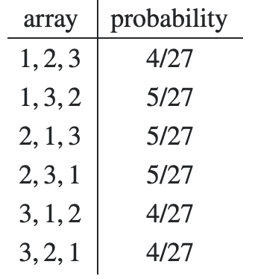

there are three permutations each being produced by 4 and by 5 choices of random numbers, so some permutations *must* be more likely than others.

For n = 2 this argument doesn't show any problem since 22=4 is divisible by 2!=2 , and indeed the algorithm produces a random permutation.

A-19.3

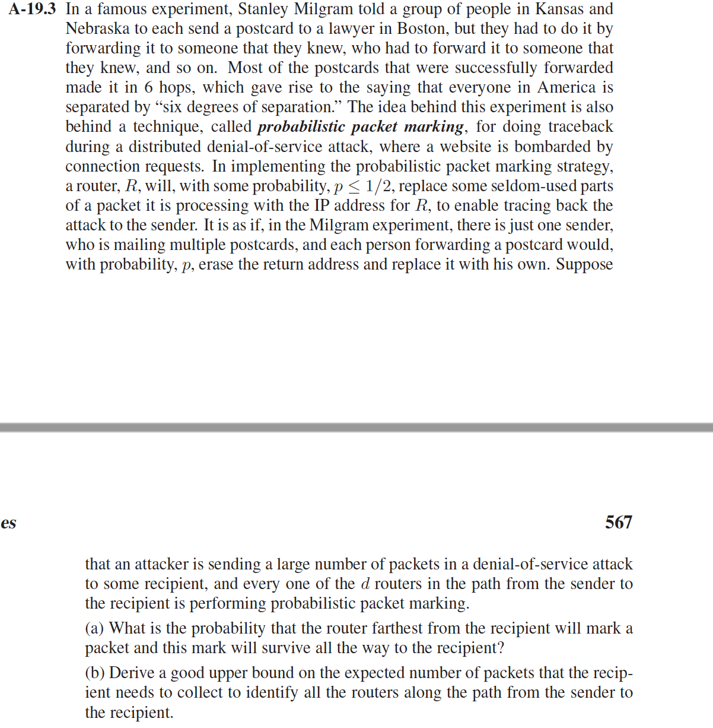

Answer:

1. the probability of receiving a marked packet from a router d d hops away is
2. We can bound this effect to a factor of . by the following argument: We conservatively assume that samples from all of the d routers appear with the same likelihood as the furthest router. Since these probabilities are disjoint, the probability that a given packet will deliver a sample from some router is at least . Finally, as per the well-known *coupon collector* problem, the number of trials required to select one of each of d equiprobable items is .

Therefore, the number of packets X, Grequired for the victim to reconstruct a path of length d d following bounded expectation: